The 3 Step Guide to Hosting a Climate Conversation
We need to talk about climate change. WHY talking about climate change is so important – most important thing you can do!

The aim of the climate conversation is to explore how we can act collectively on climate change. The conversation is a space to reflect personally and collectively:
- Welcome and introduction
Welcome everyone to the climate conversation. You could introduce Margaret Wheatley’s “principles of a good conversation” (see below)

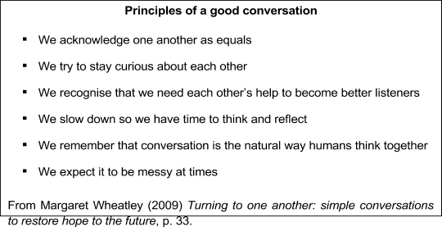

- Getting to the root of climate change (15 mins)
Use mobile phone stopwatch!

- Invite each person to write down an answer to the question ‘why is climate change happening (in your opinion)?’ (2 mins)
- Working in pairs, each person offers their answer and the other person asks ‘But why?’ The person answering should try to answer as many ‘but whys’ as possible. (3 mins each)
- Invite the pairs to share their thoughts with the whole group and have a chat together. What were peoples starting points? Where did they end up? Record the root causes that the group identifies. (7 mins)

- From old roots to new shoots (20 mins)

- Working in pairs, look at the ways in which the root causes of climate change appear in our own lives, personally and in our communities. (5 mins total)
- Group conversation - What are the common themes or ideas? (5 mins)

- What actions could the group take to address some of the root causes they have identified? (10 mins)

- Now and into the future (25 mins)

- Swap pairs around and have a discussion around how you’re getting on as a Climate Ambassador.
  - What’s working well? (2 mins each)
  - What networks are you part of (any new ones?)
  - What new initiatives/campaigns are you undertaking
  - What plans do you have

- Where are you having difficulties and what help might you need? (2 mins each)
  - What are they finding difficult
  - What support they may need

- Group conversation to share feedback. What new ideas have you taken on board? What might you now try? Or what might you now try differently? (15 mins)

TRIM AND EDIT THE ABOVE DOWN TO ONE SLIDE WITH A FEW BULLET POINTS

At the end of the Climate Conversation:

Invite group to sign up to host a gathering in their home/school/workplace with a new group of people.

Background details - Climate Conversations Guide:

Overarching Narrative (Climate for Change);
- Climate change is a serious urgent issue - it affects all of us.
- Solutions are available and ready.
- People with power are not acting fast enough
- People with power are holding us back
- All over the world the movement is growing
- Ordinary people are driving the movement for change
- But we’re running out of time…
- We need to act now; stand up, reach out, be informed.
- What groups are active in my neighbourhood / area of interest
- Who can I target - politicians, leaders, decision makers, producers, businesses
- Next steps - up to the group / individuals

The Gathering - Step by Step

5. Bring it home (info to have available but not for telling people)
What impacts will climate change have in Ireland?
What is Ireland’s current position on climate change?
What solutions do we have in Ireland, could we be doing more?
Who is holding us back - who’s making the decisions - who’s benefiting from these actions?
What role does Ireland play in the bigger global picture of climate change?

8. Power of grassroots change -

The movement needs all of us in order to bring the change - Climate movement is intersectional.
We still have time - BUT - we need to act now.

